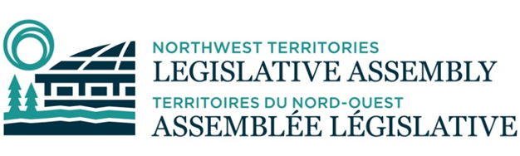
COMMITTEE RECORD OF PROCEEDING
MEETING 018-20-24 OF THE STANDING ON ACCOUNTABILITY AND OVERSIGHT
MONDAY, AUGUST 12, 2024 AT 4:00 P.M.
DET’ANCHOGH KŲ́É - EAGLE ROOM

Acting Chair Morse called the meeting to order at 4:06 p.m.

Committee Members in attendance: Rodgers, Morse, Edjericon, Reid, Hawkins, Weyallon-Armstrong, Morgan, Testart, Nerysoo, McNeely.

Regrets: Yakeleya

- Prayer was conducted by MLA Weyallon-Armstrong
- MLA Reid moved the adoption of the agenda as amended. Carried.

- There were no declarations of conflicts of interest.

- Public Matters:
  - No Public Matters

MLA Reid moved that Committee move in-camera for the following items. Carried. Committee moved in camera at 4:07 p.m.

- In Camera Matters
- Confidential Correspondence:
    - 2024-06-12 - LP: Municipal and Community Affairs Statues Amendment Act
    - 2024-07-25 – LP: Public Service Act
    - 2024-07-26 – Correspondence – Minister of Education, Culture and Employment
    - 2024-08-02 – Correspondence – Premier of the Northwest Territories
- Infrastructure Acquisition Plan

- New Business:
  - Committee Collaboration Discussions

MLA Morgan moved that Committee conclude in-camera matters. Carried. Committee concluded in-camera matters at 6:00 p.m.

- Date and Time of Next Meeting: At call of Chair.

- MLA Edjericon moved to adjourn the meeting. Carried. The meeting was adjourned at 6:01 p.m.

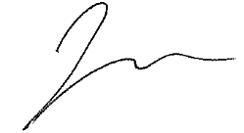
________________ ________________
Julian Morse, Acting Chair Harjot Sidhu, Committee Clerk

